8th Grade Unit 5: Exploring Space

Lesson 1: What can we learn from images from space and how do we get them?
Vocab: wavelength, electromagnetic spectrum, spectrum, space shuttle, lander, probe, rover, orbiter, artificial satellite, NASA

Energy travels through space as electromagnetic radiation (light).
- Moves as waves
- Described by frequency (number of waves per second) or wavelength (distance between adjacent crests or troughs)
- Higher freq. = lower wavelength
- Lower freq. = higher wavelength
- Higher freq.= more energy
Light energy is put onto a spectrum ( a range of a single feature) based on wavelength
called the electromagnetic spectrum

Longest wavelength Shortest wavelength
(ROY G. BIV)
Radio Microwave Infrared Visible Light Ultraviolet X-ray Gamma Ray

*only images created with visible light can be seen w/out computer enhancement

- Do NOT need matter to travel
- Cool things emit radio waves hot things emit visible light hotter things emit gamma rays
- Only portions of the em spectrum reach the surface of Earth
- 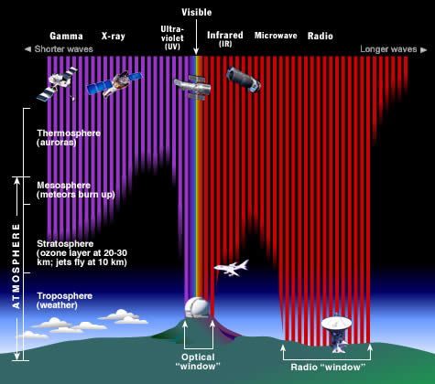
- Atmo. filters out a lot of the em spectrum (ex. CO₂ absorbs infrared, O₂ absorbs x-rays and gamma) affects where we can put tools to study the light from space
Telescopes
- Can be land or space based depending on the type of em. light they are searching for
- Optical telescopes
  - Visible light collected with mirrors or lenses
  - Mirror telescopes are called reflecting telescopes
  - Lens telescopes bend or refract the light to your eye; refracting telescope
  - Bigger lense/mirror= more light = see farther
- Non-optical telescope
  - Collect other wavelengths of the em spectrum
  - Radio telescopes often work with mirrors
  - Radio waves are very big so the radio dish is big
  - Images are created on a computer
- Remote sensing is observations of Earth from space
  - Atmospheric satellites are in low-Earth orbit (few km above)
  - Geosynchronous satellite is always above the same location on Earth
  - Can help to study changes in an area over time (population, environment, etc.)
Manned exploration
Rockets-carried a capsule with people into orbit/space
Space station- a research lab in Earth’s orbit; used for long term studies in space environment
Space shuttle- a reusable spacecraft that launches w/ the aid of rocket boosters and liquid fuel
Unmanned exploration
- Telescopes
- Probe- unmanned vehicle that carries instruments to collect data from far away
  - Studies atmospheres of other planets
- Orbiter- designed to enter into orbit around another body
  - Study a planet for a long period
  - Lander- lands on the surface of a planet
    - Give detailed info about the surface
    - Rover- small vehicle that comes out of the lander to explore the surface
    - Artificial satellite- man made object that orbits another body in space
      - Used to study the geography of space, monitor changes in Earth’s systems, collect weather data, search and rescue, composite images (removes cloud cover), communication, sending information to far location on Earth, GPS (global position system)
NASA- National Aeronautics and Space Association whose purpose is to work for the development, research and “conquest of space”

1957-Sputnik first satellite to orbit Earth
1961-First person to orbit Earth; Yuri Gagarin (Russia)
Second was Alan Shepard (US)
1962-Mariner 2 to Venus
First TV satellite
1963- first woman in space (Russia)
1969- Apollo 11 first to land on Moon; Neil Armstrong and Buzz Aldrin
Apollo missions 68-72; 12 people walked on the moon
1971-Salyut is the first space station
1972-Pioneer 10 traveled inside Jupiter’s rings
1976- Viking 2 lander landed on Mars
1981-Shuttle flights begin
1986-Challenger shuttle explosion
1989-Galileo space probe to study Jupiter
1996-Sojourner lander on Mars using x-rays
1997-Cassini-Huygens probe to study Enceladus, Titan, and Saturn
1998- International Space Station (ISS) is a long term research lab in space
2003-Columbia shuttle explosion
2004-Spirit and Opportunity rovers on Mars
2005- landed an impactor on a comet to study the inside
2009-NOAA polar orbiter weather satellite

