6th Grade Unit 5: Cells
Lesson 1: What are living things made of?

What is a cell?
- All living things are made up of _______
- Cell-

- Organism-
- An organism carries out all of its own _________ _______________ using
_____-______________ of cells
- ____________ ____________ was the first person to observe them and saw that they looked like little boxes which he called cells (in Latin means “_____________ ________________”)

Why are most cells small?
- Most are too small to be seen without a ___________________
- Their size is limited by their outer ____________ ______________
- Take in __________ and get rid of ____________ through their outer surface
- Bigger cell need to move ________ in and out and need a larger _________
- ______________ increases faster than surface area as a cell grows
- Big cells don’t have enough __________ __________ to take in and pump out materials
- Cells need a greater _____________-to-_____________ ratio

- volume = length x width x height
- area= length x width
- Surface area of a cube= the number of faces x the area of one face

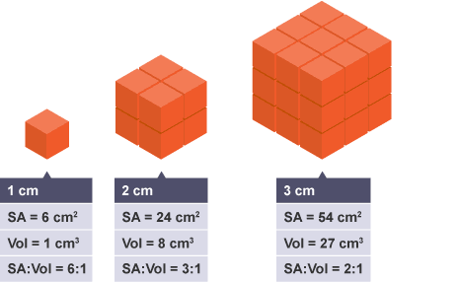
What is the cell theory?
- Scientific knowledge often _______________ the work of several people.
- Discoveries by Mathias Schleiden, Theodore Schwann, and Rudolf Virchow led to the ______ _____________.
- It lists ____ basic characteristics of all _________ and _________________:
  - All _________________ are made of 1 or more cells.
    - Anton von Leeuwenhoek observed the first living cells
    - Schleiden said all ____________ were made of cells (1838)
    - Schwann said all _____________ were made of cells and included all organisms in the theory
    - Unicellular-
    - Multicellular-
      - Cells of multicellular organisms have special _____________
  - The cell is the basic ____________ of all organisms
    - Schwann saw that parts of cells cannot do all the necessary ____________ of life ,and so, you can not divide organisms into any smaller _____________
  - All cells come from _______________ cells
    - Virchow proposed that cells can only come from the _____________ of other existing cells
- It is used in the studies of biology, evolution, and other __________ sciences.

What parts do all cells have in common?
- Cell parts each carry out specific jobs or _________________.
- All cells (no matter the _________) have:
  - Cell membrane-

    - Acts as a ____________
    - Controls materials like ___________ and ___________ that move in and out of the cell
    - Aka ______________ membrane
  - Cytoplasm-

    - Includes all of the _______ and ______________
  - Organelles-

    - Cells can have _____ or ________ types
    - most (but not all) have a ________________
  - DNA (deoxyribonucleic acid)-
    - Inherit from _______________
    - In some cells it is in the ________________ and in some it is in the ___________________ freely floating

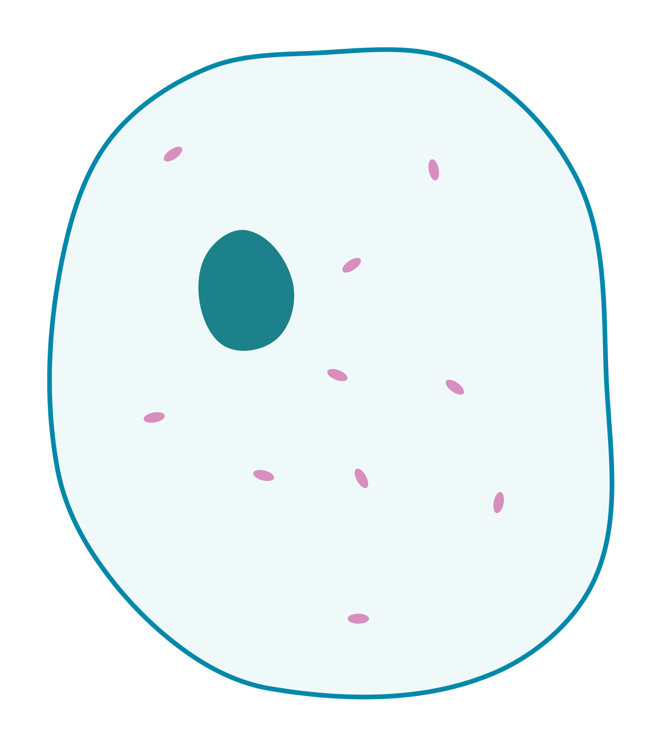(label the parts that all cells have)

What are the two types of cells?
- Prokaryotic cells
  - Prokaryote-

    - Has organelles called _________________ that do not have a _______________
    - Some have a hair-like tail called a _________________ that help them ____________
    - Include the organisms in the kingdoms _________________ and ________________
    - Are _________________ than eukaryotes

Label the type of cell in the diagram
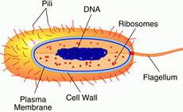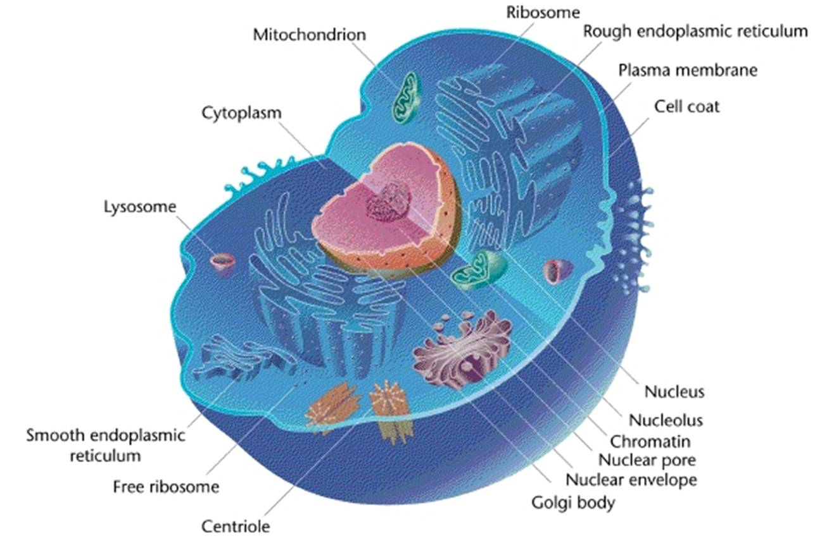

- Eukaryotic cells
  - Eukaryote-

    - Contain membrane-bound ______________
    - ___________________ (organelle w/out a membrane)
    - Includes the ______________ plantae, animalia, fungi, and protista
    - ALL _________________ organisms are eukaryotes
    - Some eukaryotes are _________________ like yeasts and amoebas

